
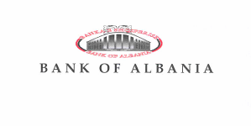

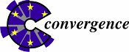
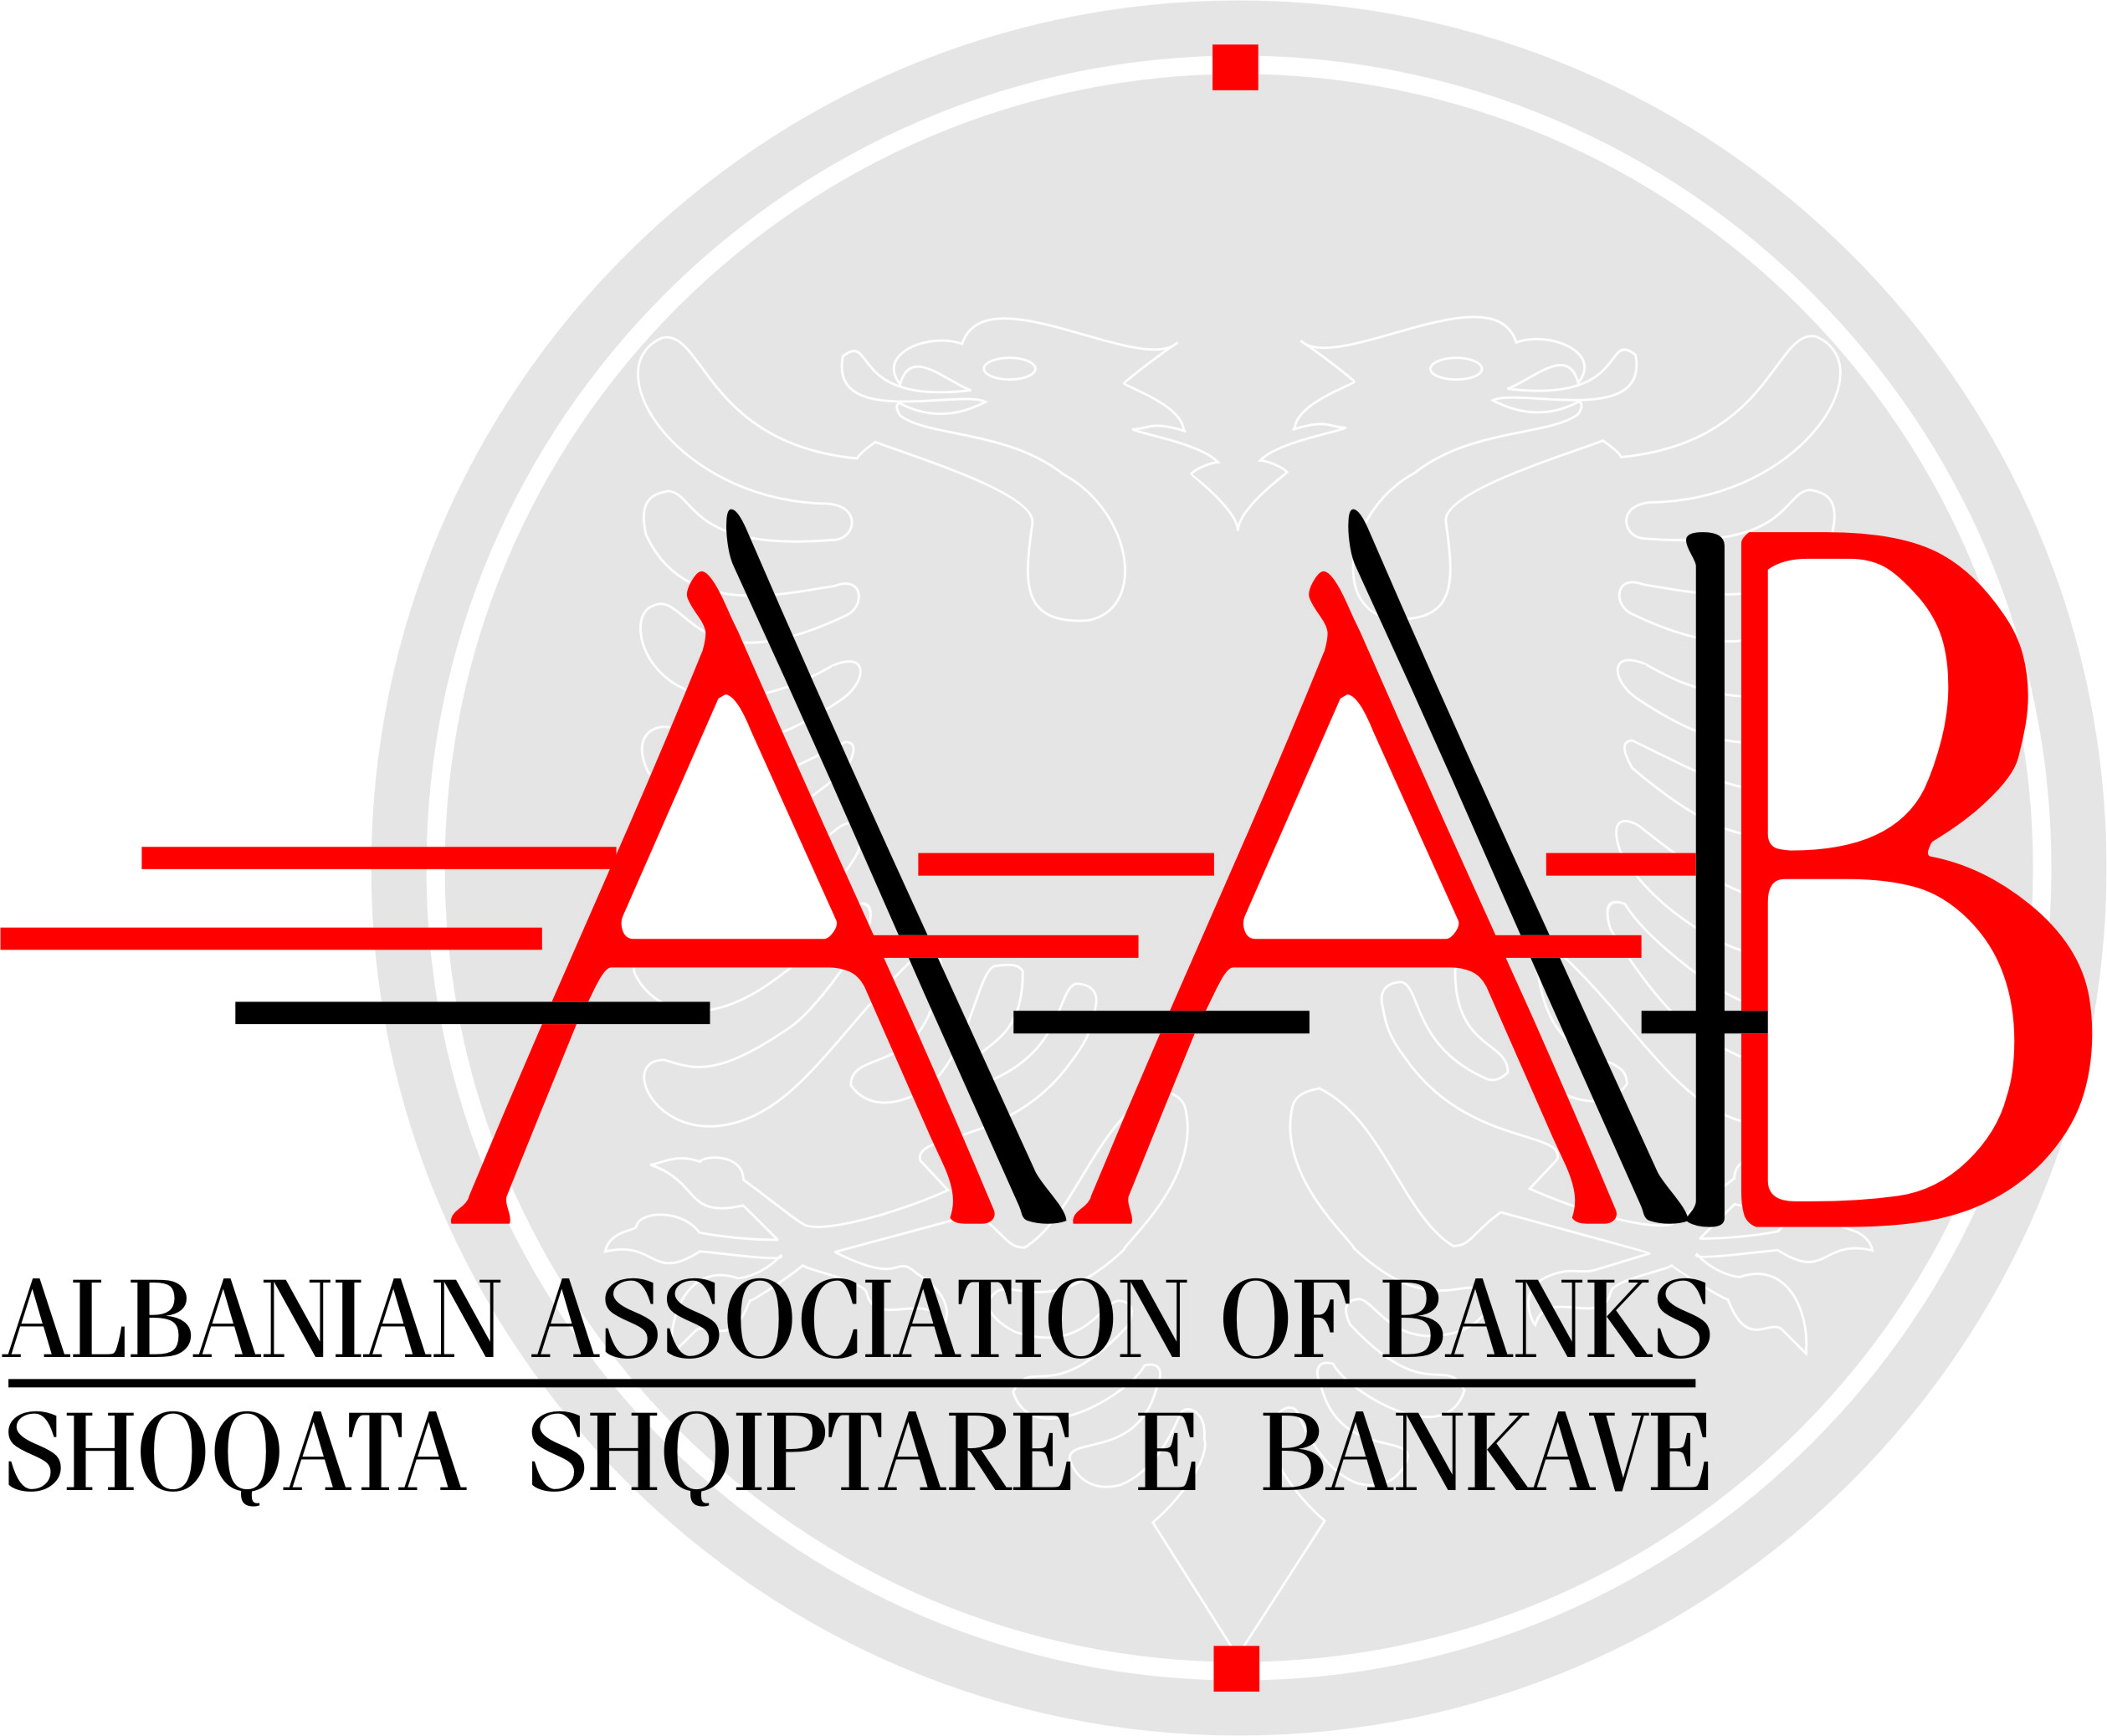

SPI ALBANIA –
AN INITIATIVE FOR ALBANIA FINANCIAL SECTOR MODERNIZATION

1. Context and particularities of the partnership

With World Bank’s Convergence Program support, Bank of Albania and the Albanian Association of Banks joined forces in January 2008 in order to create the SPI Albania public-private partnership to mobilize local expertise to address financial sector modernization opportunities that were unmet by donor assistance.

The partnership is led by an SPI Committee, where are represented top level officials of its partner institutions: Bank of Albania, Albanian Association of Banks, Financial Supervision Authority, Ministry of Finance and Ministry of Economy, Trade and Energy. The SPI Committee meetings are chaired by the First Deputy Governor of Bank of Albania.

2. Objective

SPI Albania’s objective is to develop the management processes and methodological tools to support a multi-annual large-scale financial sector modernization program. A financial modernization program aims at creating new financial intermediation opportunities through removal of market failures. It complements traditional financial work that strengthens prudential regulations on existing financial intermediation.

In the SPI Committee’s vision, the SPI Platform is emerging as the financial modernization hub, facilitating programmatic focus, donor coordination, local capacity-building with a strong result orientation.

3. Status of partnership to date

The partnership is being supported by World Bank-administered Convergence Program, on a Build-Operate-Transfer mode. Starting from March 2010, SPI Albania is projected to operate under full local responsibility. In early 2009, the partnership was reinforced through two Memorandum of Understanding signed with the European University Tirana and with the Italian Banking Association who appointed Permanent Observers to the SPI Committee.

4. Structure, processes and milestones

4.1. SPI Albania structure

SPI Albania is led by SPI Committee gathering top-level representatives of the local stakeholders. It approves an Annual Financial Modernization Program, prepared by the SPI Secretariat after extensive consultations with local stakeholders and the donor community, reviews work-in-progress and endorses the final outputs of the program.

The Program is executed by public-private working groups of local experts, led by a Project Owner assisted by a Project Manager and Project Co-Manager acting as Project Management Group, which carry out analyses and prepare proposals for regulatory changes based on EU Better Regulation methodologies. Proposals are signed off by the Project Management Group and eventually endorsed by the SPI Committee before being transmitted to relevant authorities for their consideration.

A permanent 2-person SPI Secretariat (Director for Operations and the Director for Financial Modernization Program and Analytics) complemented by a part-time consultant under SPI Regional Operations Director’s coordination (as Head of SPI Secretariat) support the partnership activities.

The SPI Secretariat has been selected in a very competitive manner, through a four steps recruitment process, including interviews with local stakeholders’ representatives, human resources specialist’s assessment, and team evaluation sessions. Selected SPI Secretariat has been provided training and is given permanent coaching.

SPI Secretariat acts as a convener, performs studies in the international experience, undertakes regulatory impact assessment and runs surveys and consultations, as well as prepares all project documents, including drafting the final PWG recommendations. One of its main responsibilities is ensuring consensus building among various stakeholders. Its performance is assessed by Project Working Group members through a structured questionnaire filled at the end of each project.

When necessary, international experts are invited to provide complementary perspectives to Project Working Group expertise. Through this angle, SPI Albania is a powerful coordination platform for donor activities in the financial sector.

SPI Albania’s operating principles are as follows:

1) Local ownership
By local ownership we mean that local stakeholders a) decide the SPI Albania program after broad consultations with the community and b) endorse the specific project recommendations first at the expert level and then at the SPI Committee level before transmission to the relevant authorities as an input in their decision-making activities. It also means that the local community contributes to the activity through large mobilization of their experts and by covering an increasing share of its operating expenses.

2) Programmatic focus
The SPI Committee approves an annual financial modernization program, prepared by the SPI Secretariat after extensive consultations with local stakeholders. In the context of the policy priorities set by the Governor of Bank of Albania in his policy speeches in Banking Forum meetings, the program reflects the local stakeholders’ priorities for reducing asymmetric information, for completing the market, for increasing opportunities to engage in financial transactions, for reducing transaction costs, and for enhancing competition. These principles are drawn from the European Central Bank taxonomy to measure progress on financial integration.

3) Mobilization of local expertise
The program is executed by public-private working groups of local experts, led by a Project Management Group. The Project Management Group consists of a Project Owner who appoints the Project Manager, representing the main stakeholder of the project, and a Co-Project Manager on behalf of the other main stakeholder.

4) Involvement of foreign experts to fill local knowledge gaps
The Project Working Groups carry out analyses and prepare proposals for regulatory or self-regulatory changes. When necessary, Project Working Groups invite international experts to provide complementary perspectives to their expertise.

5) Disciplined program management
In order to reach the objectives in an effective way, Project Working Groups run the projects according to specific and very detailed Terms of Reference prepared by the SPI Secretariat. The project steps are based on the standard documentation, based on the EU Better Regulation methodology, to be prepared and discussed in 4 Project Working Group meetings within about 3 months. Project Working Group recommendations are signed off by the Project Management Group and eventually endorsed by the SPI Committee before being transmitted to relevant authorities for their consideration.

6) Evidence-based analytical methods to search for solutions
Each project follows closely the EU Better Regulations methodology whose main principles are the consultations on policy options with stakeholders and use of Regulatory Impact Assessment as a tool for providing supporting evidence for regulatory proposals.

7) Full transparency of our work
SPI Albania made its governance framework, its activities, projects and documents available to the public through its website, through events and bilateral meetings, as well as through other communication channels.

8) Strong practical impact orientation
SPI Albania results are measured not in studies or proposals, but in enacted regulatory or self-regulatory changes. Please see 5 below.

4.2. Processes

SPI Albania has comprehensive operating guidelines covering the activities of its organizational structures, standard documents and project management, using EU Better Regulation approach.

4.3. Milestones

January 2008 Bank of Albania and Association of Albanian Banks send Joint Commitment Letter to Convergence Program
January SPI Seminar with banking community
Jan-Mar Regulatory Impact Assessment Program
Feb-Mar Consultations to build 2008 Activity Program
SPI Secretariat recruitment

15 May SPI Secretariat starts working
10 June First SPI Committee meeting
Approved SPI Albania 2008 Activity Program (6 projects)
Approved SPI Committee Operating Guidelines
19 June Start of first 4 projects by PO appointing
3-4 July First PWG Meetings
4 November Second SPI Committee meeting to approve first 3 PWG
recommendations
11, 29 December Parliament enacts the 2 laws promoted by SPI Albania

14 January 2009 Start of the consultation process for building up the 2009
activity program
15 January MoU with European University of Tirana
23 January Conference: SPI Albania One Year since its Inception
Release of SPI Albania 2008 annual report
9 March MoU with Italian Banbking Association
12 March Third SPI Committee meeting to approve 2009 activity
program

5. Results

SPI Albania registered by the end of last year, after about 7 months of operations, 2 laws enacted in the Parliament (one in order to amend the Civil Procedure Code on auction procedures for immovable collateral under foreclosure and the other one to promote the private bailiff service) and preparatory work in order to enable Bank of Albania’s revisions of the banking regulations for IFRS implementation. Other 3 project initiated in 2008 will be finalized soon.

SPI Albania has developed the infrastructure and processes to run extensive consultations with stakeholders, to mobilize local expertise, and to assess the impact of proposed laws and regulations to help their enactment under a robust transparency framework.

Partnership mobilization can be counted also as a relevant result:
- 27 private institutions (out of which 16 banks and 9 other professional consultants and other companies) and 6 public institutions
- 75 experts (60 experts from private institutions and 15 from public institutions)
- Value of in-kind contribution of the local stakeholders in 2008: opportunity cost for 75 experts dedicating a total of 2,400 hours to Project Working Group meetings
- Donor support– as technical assistance, peer reviewing and project working group membership: IFC, WB, EBRD, EURALIUS.

6. Challenges

The challenge in SPI Albania’s case is to ensure the transfer to local management and financial responsibilities and preserving the accumulated knowledge and operating standards.

7. Details of the author/presenter
Ramona Bratu is the Convergence Program’s SPI Regional Operations Director and acting as SPI Albania Secretariat Head. She has been previously, for two years, Director for Bank Products and Services for SPI Romania. She has an extensive banking experience in various areas and management experience and she holds a PhD in Finance with Bucharest Academy of Economics.

In July 2005, after three years of careful design, FSEVP launched the pilot Convergence Program, co-funded with a EUR1.5 million Trust Fund contributed by Italy’s Ministry of Economy and Finance with a South-East Europe focus. The Convergence Program helps create a country institutional infrastructure with incentives and skills (analytical, consultative and implementation) that support large-scale financial sector modernization programs. Feedback from market participants and financial product users, using Regulatory Impact Assessment (RIA) and market consultation techniques, is essential to design regulatory measures that effectively address market failures.

